----------

URL : https://www.amazon.com/

NOTE: Search iphones X and right click 1st phone and give open in new window

print cost of product

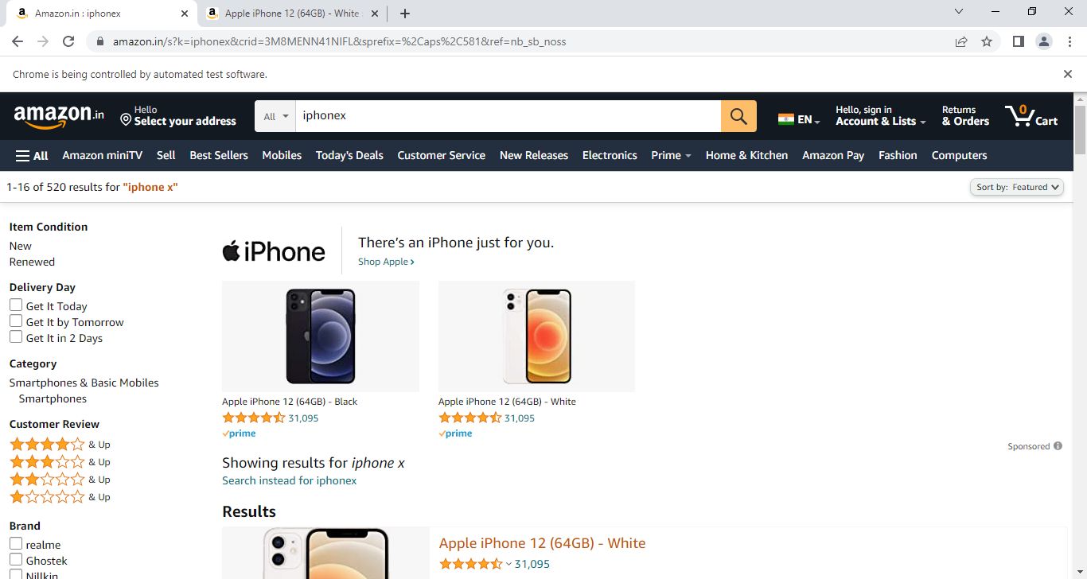

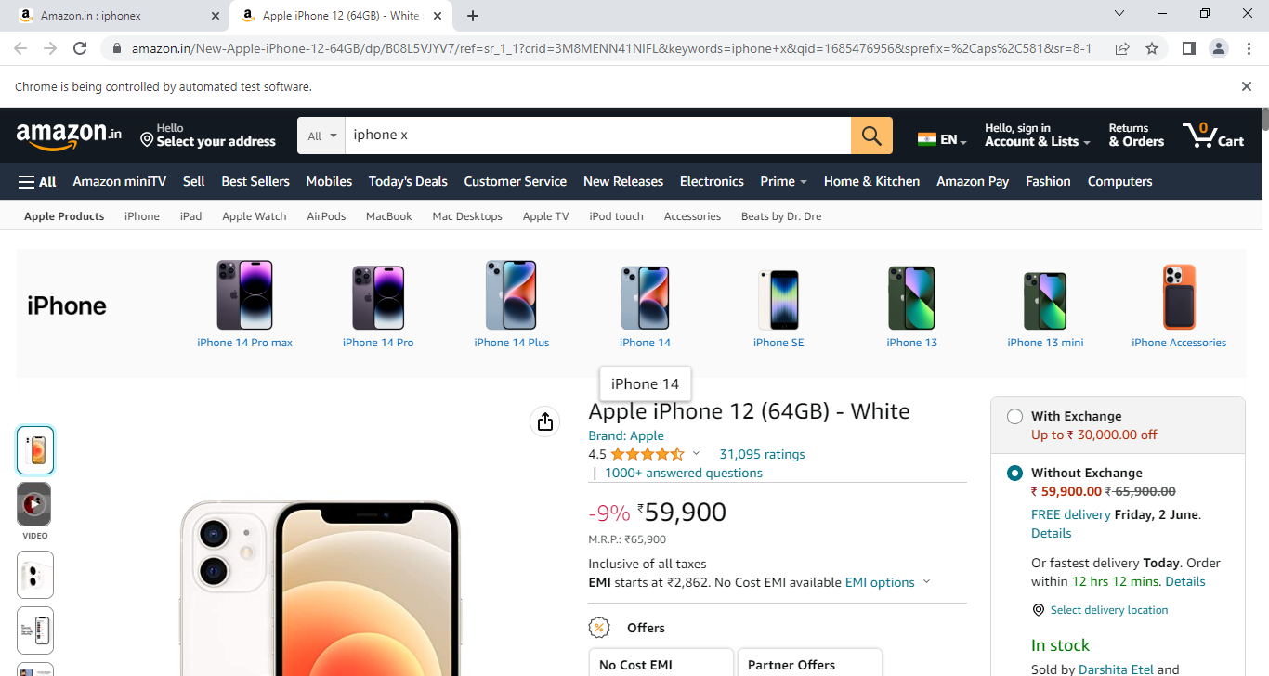

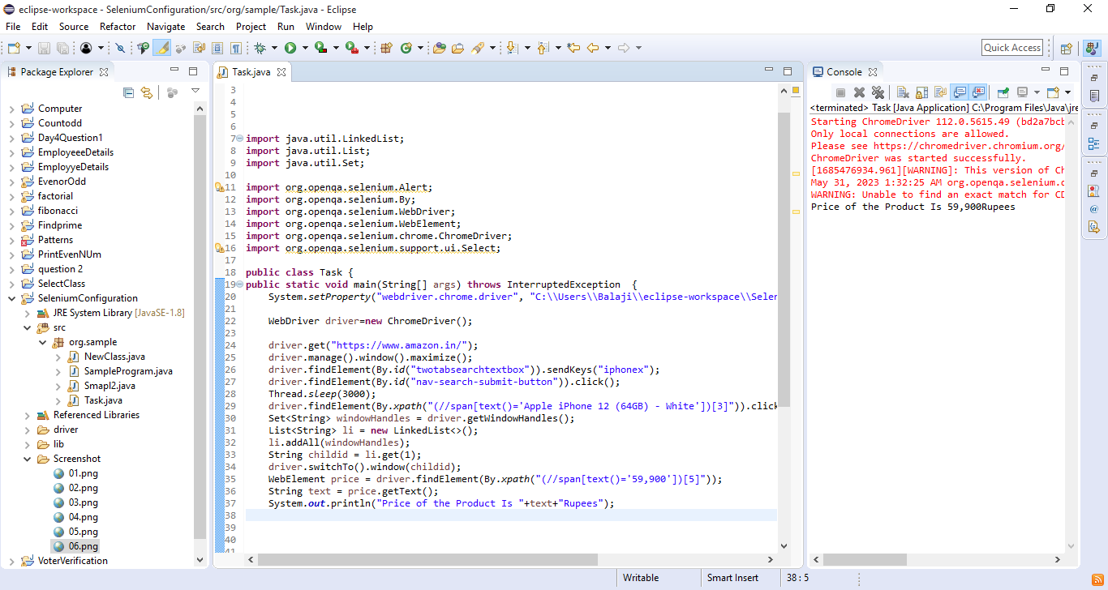

----------

URL : https://www.snapdeal.com/

NOTE: Search iphones 7 and click 1st phone

add it to cart.

print the you pay cost displayed.

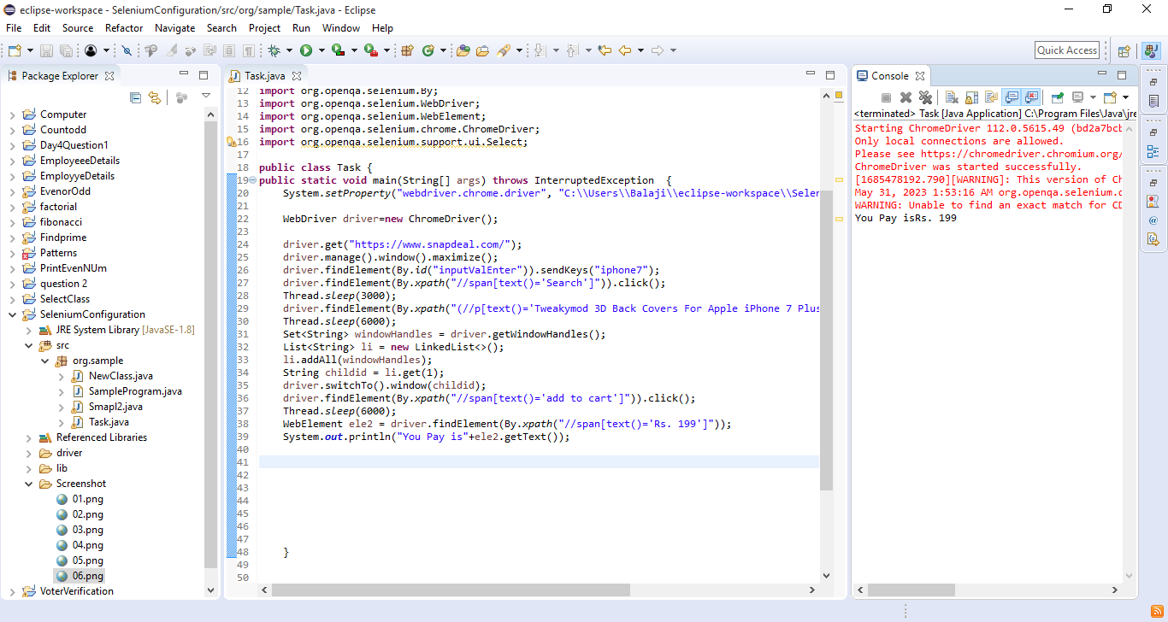

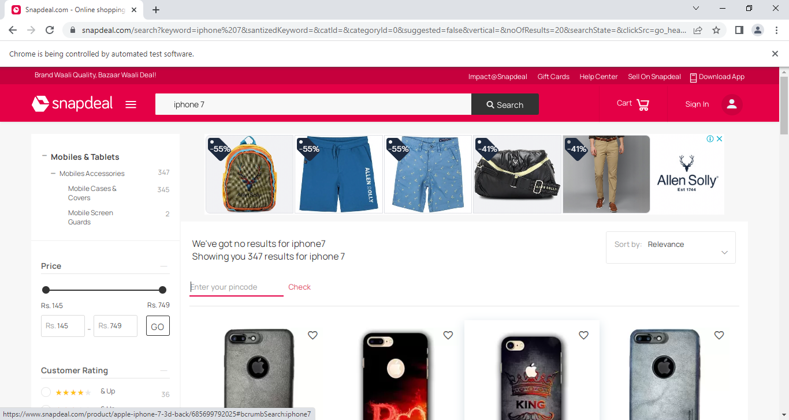

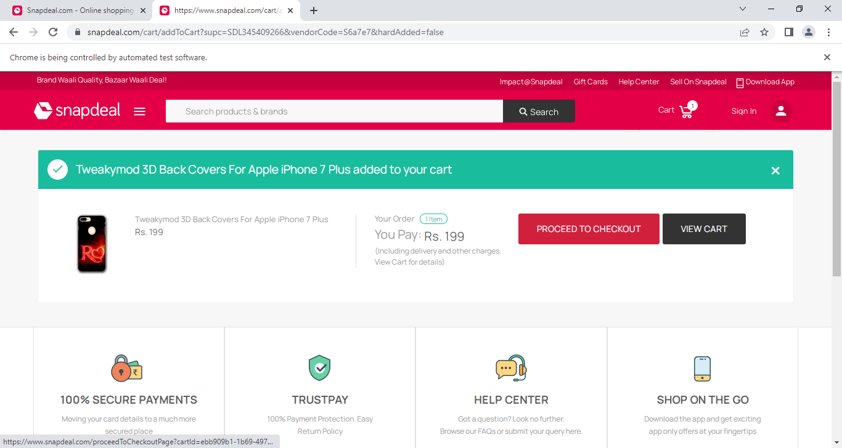

----------

URL : http://www.greenstechnologys.com/python-training.html

NOTE: Click Selenium Test Papers and click Selenium Day10Task

Click Windows Handling and print 1 question

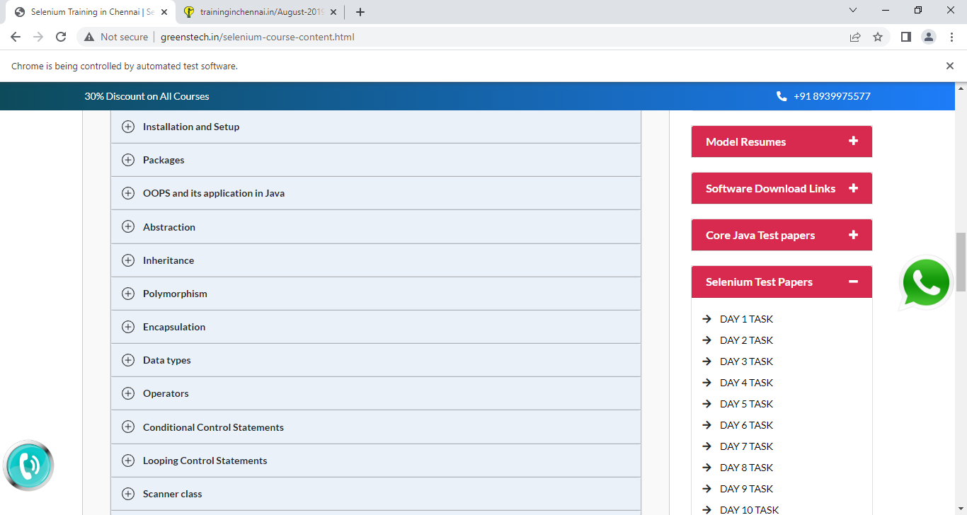

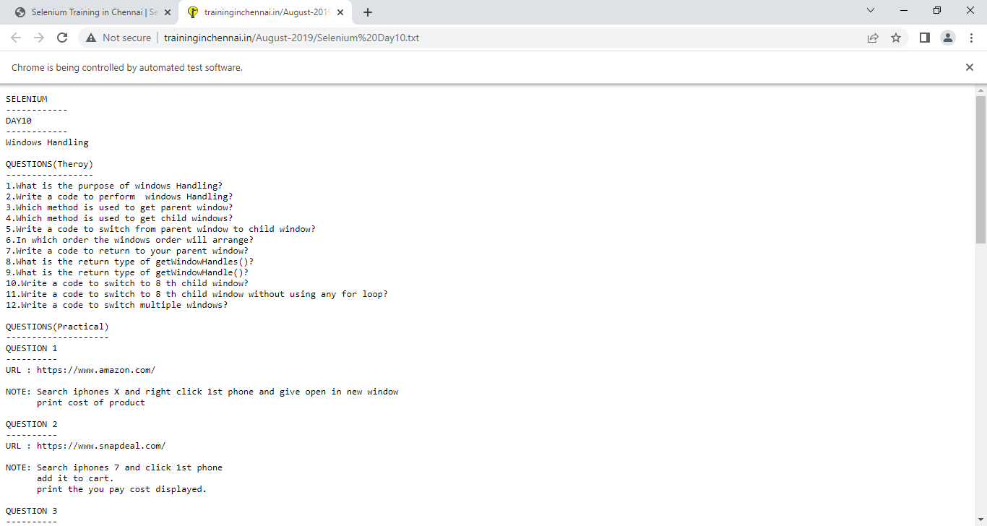

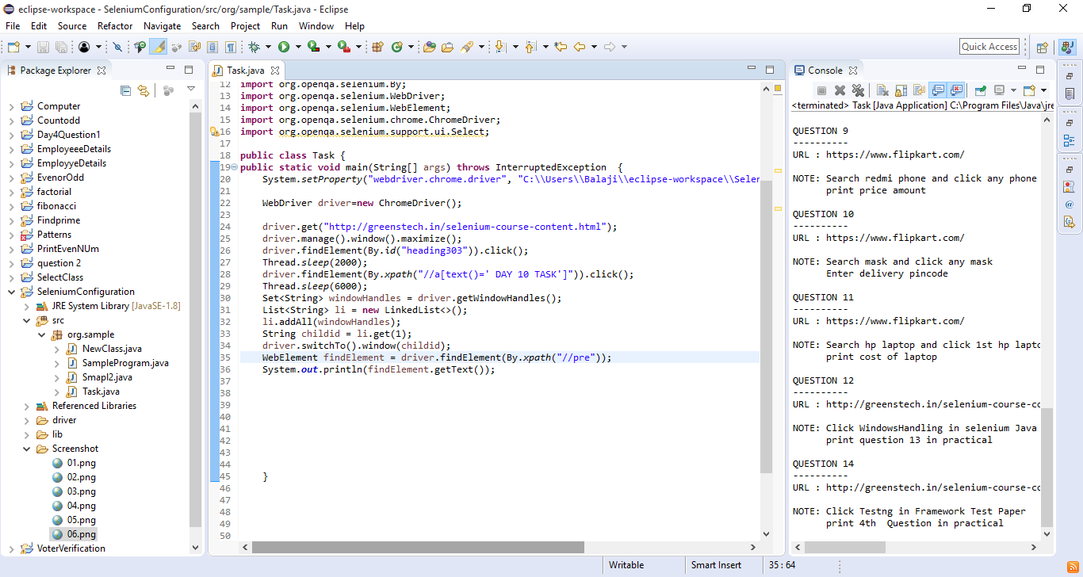

----------

URL : https://www.snapdeal.com/

NOTE: Search hand sanitizer and click any hand sanitizer

add it to cart

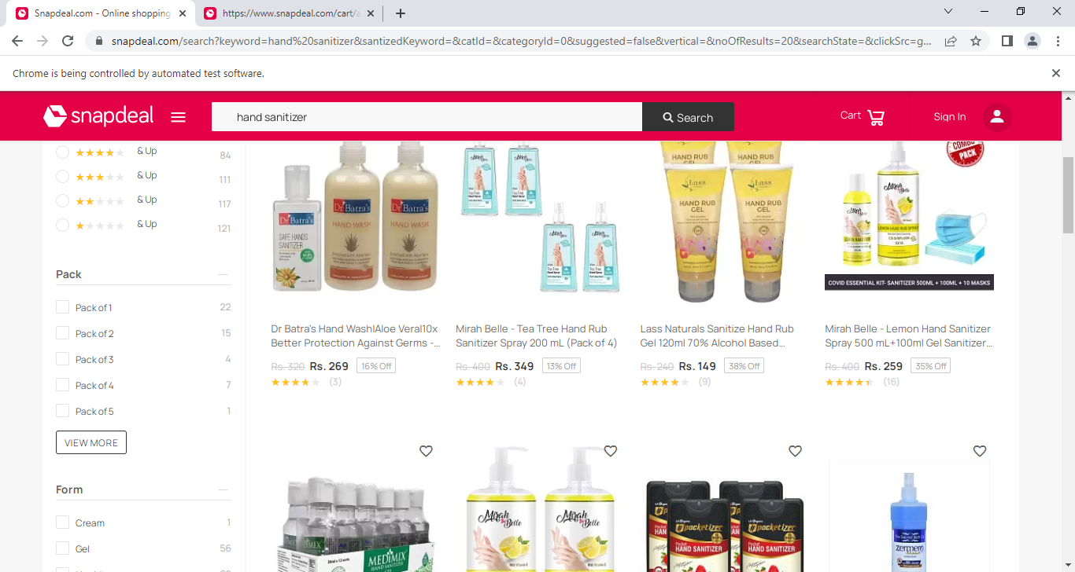

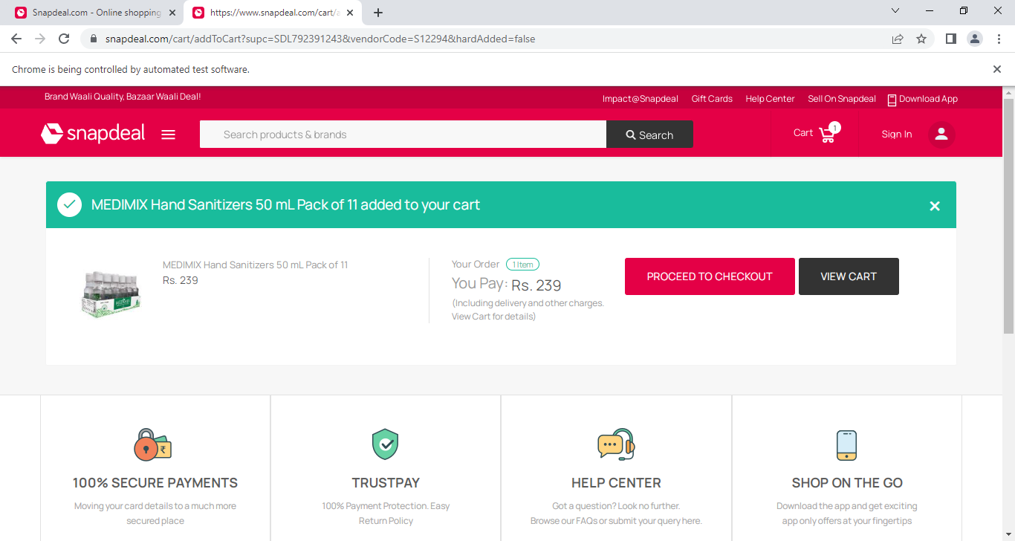

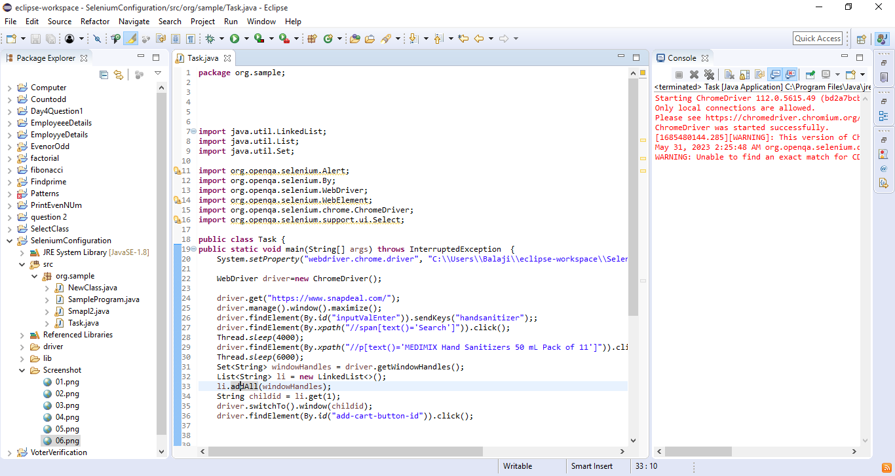

----------

URL : https://www.flipkart.com/

NOTE: Search redmi phone and click any phone

print price amount

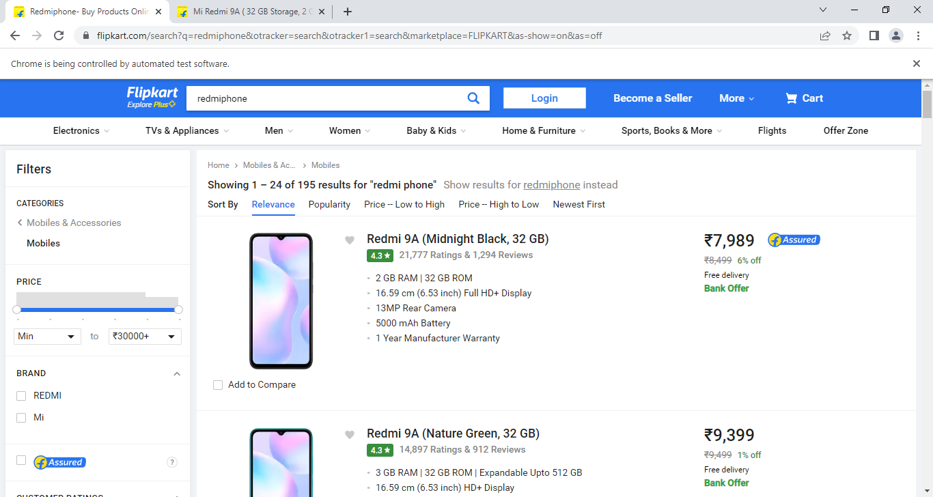

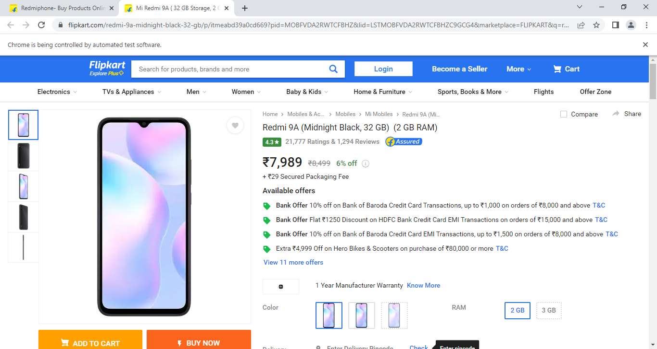

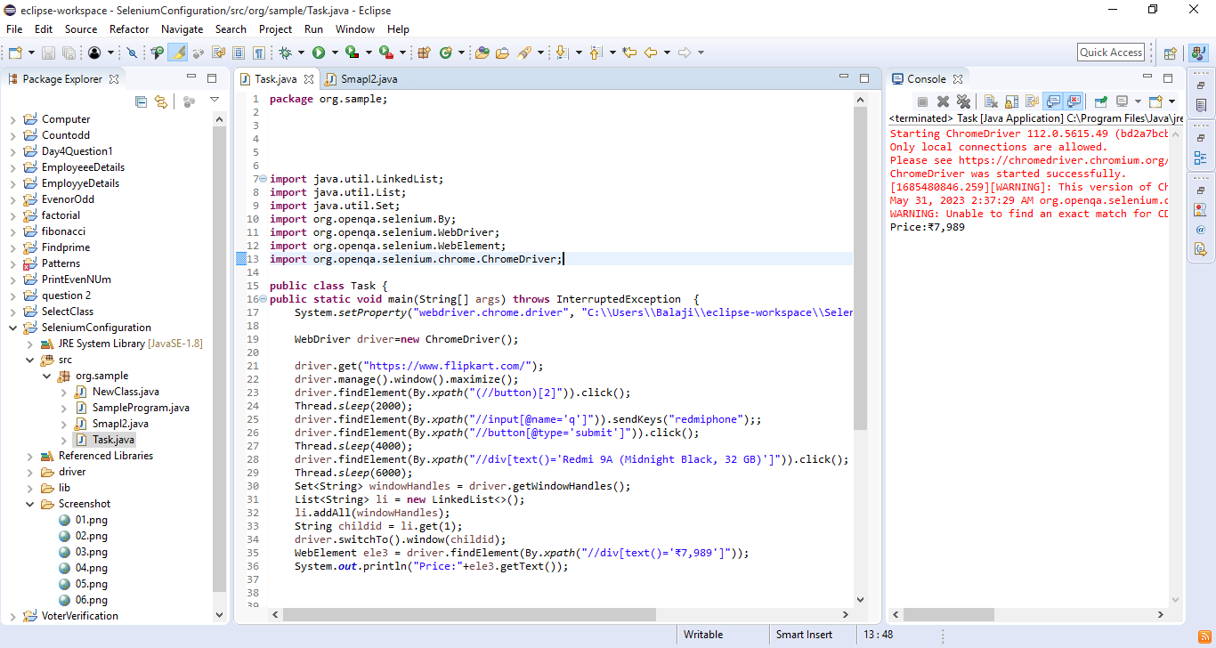

----------

URL : https://www.flipkart.com/

NOTE: Search mask and click any mask

Enter delivery pincode

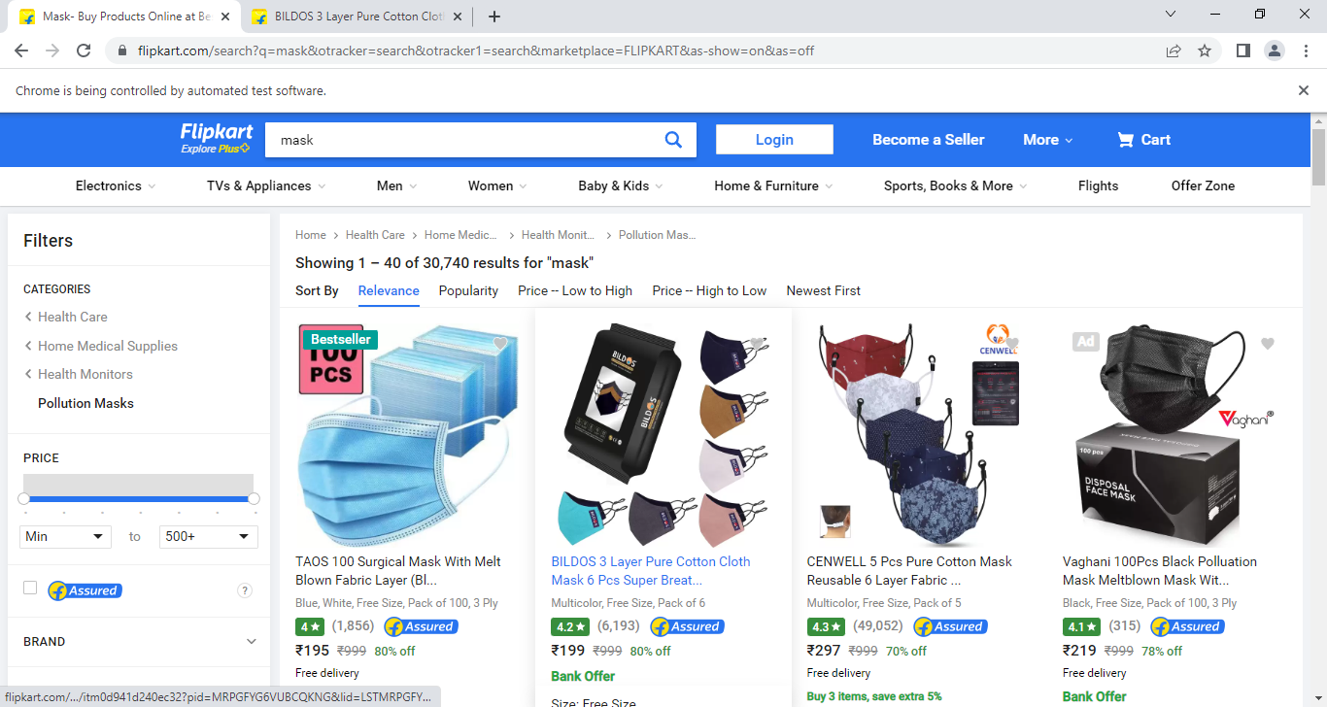

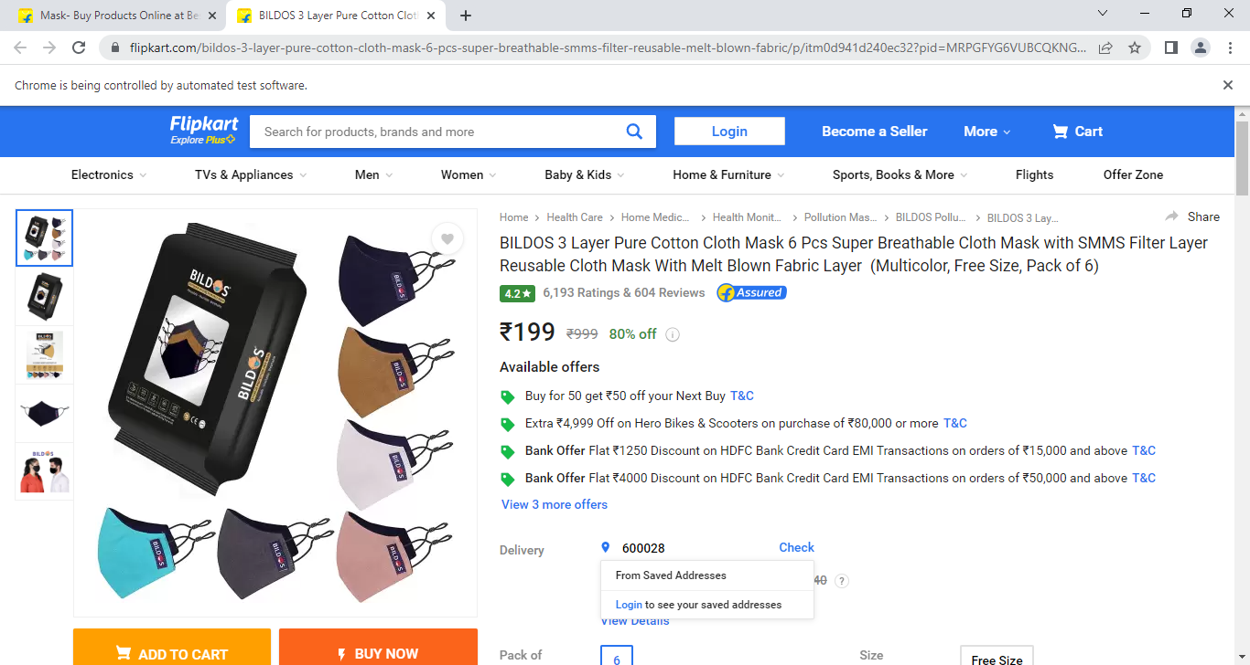

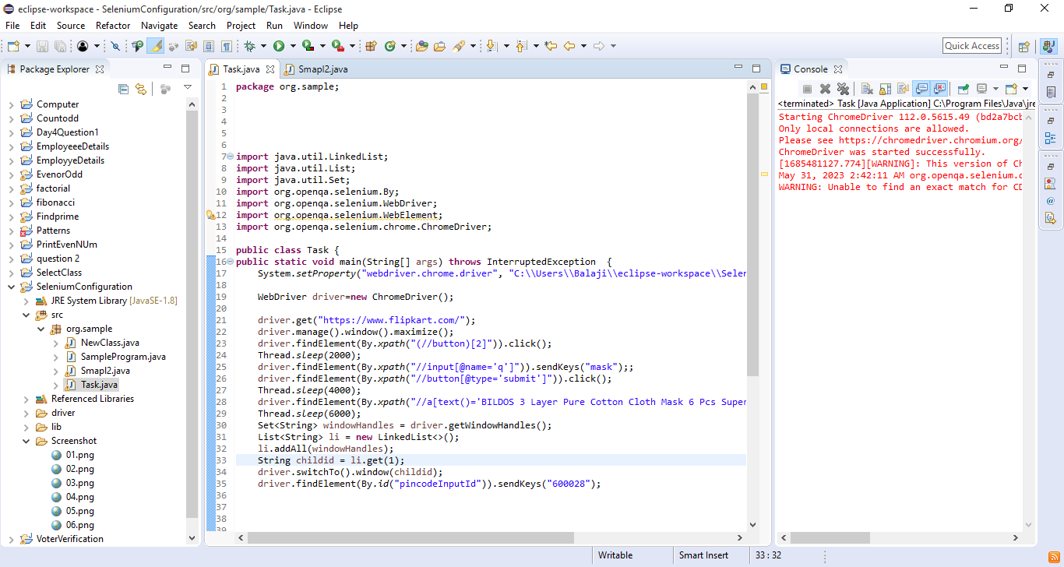

----------

URL : https://www.flipkart.com/

NOTE: Search hp laptop and click 1st hp laptop

print cost of laptop

